|  |  |
| --- | --- |
| Assignment Date | 25 September 2022 |
| Student Name | Krishnamoorthy M |
| Student Roll Number | 731619104025 |
| Maximum Marks | 2 Marks |

# Solution:

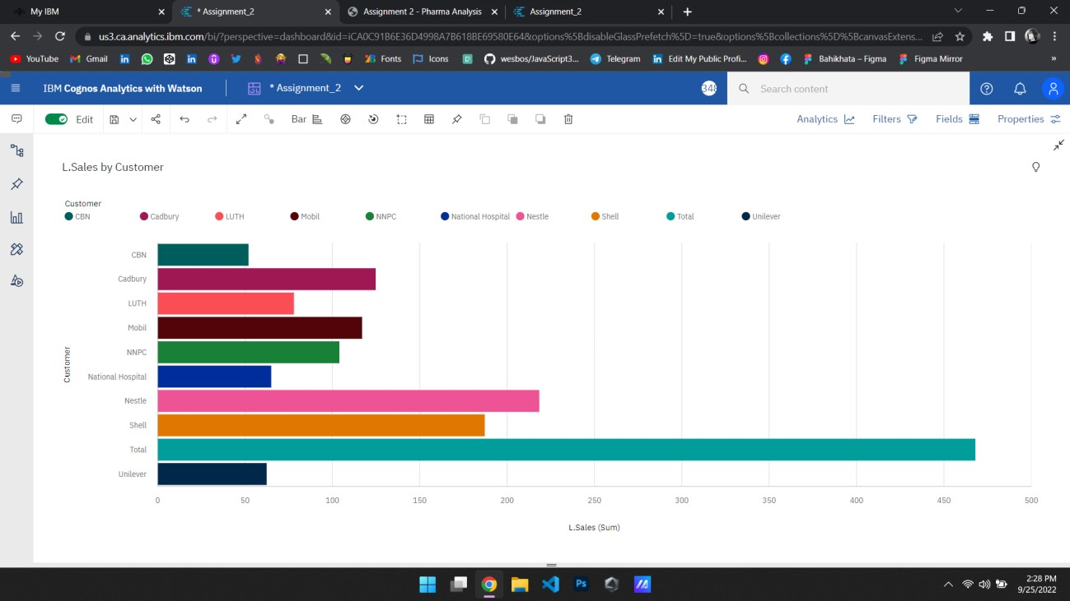



Task 1: Sales by Customer:



Task 2: Sales by Location:

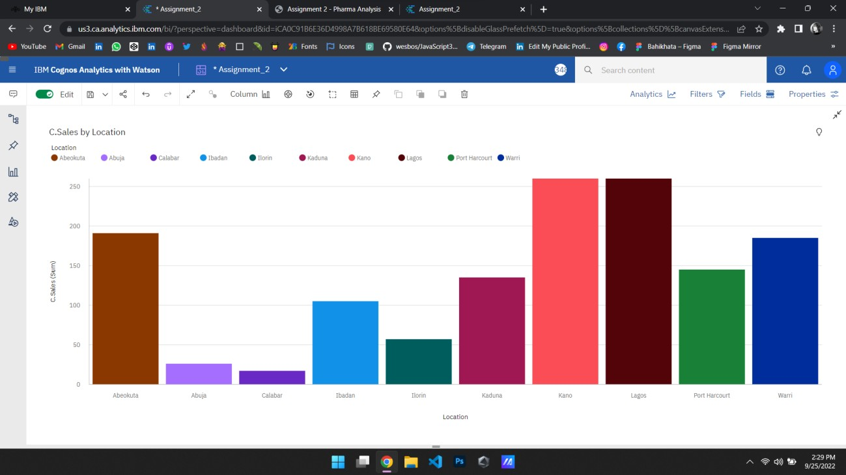

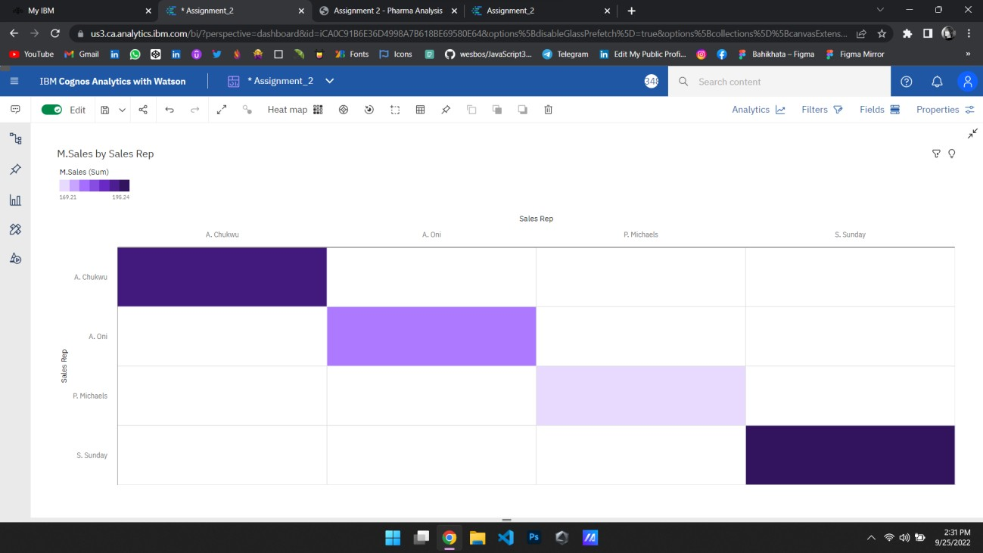



Task 3: Sales by Sales Representative:



Task 4: Received Inventory From Supplier:

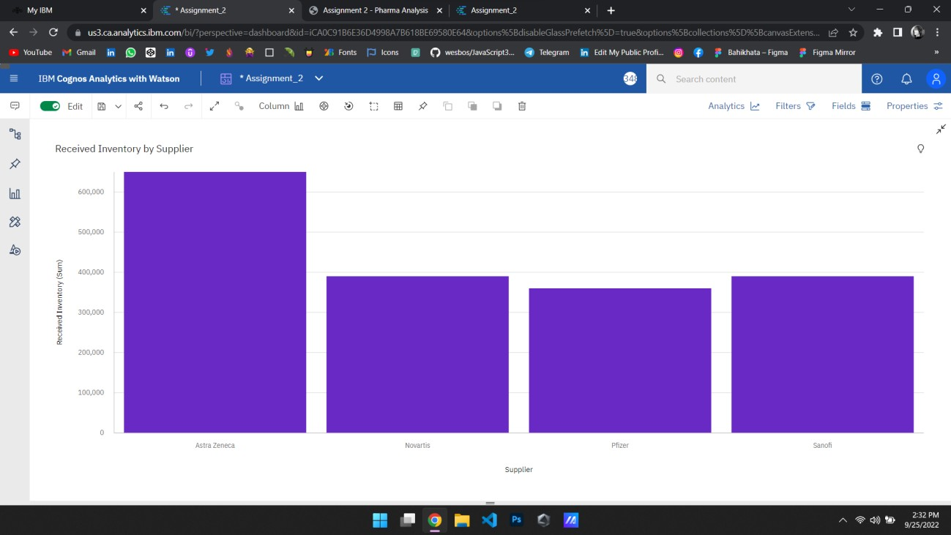

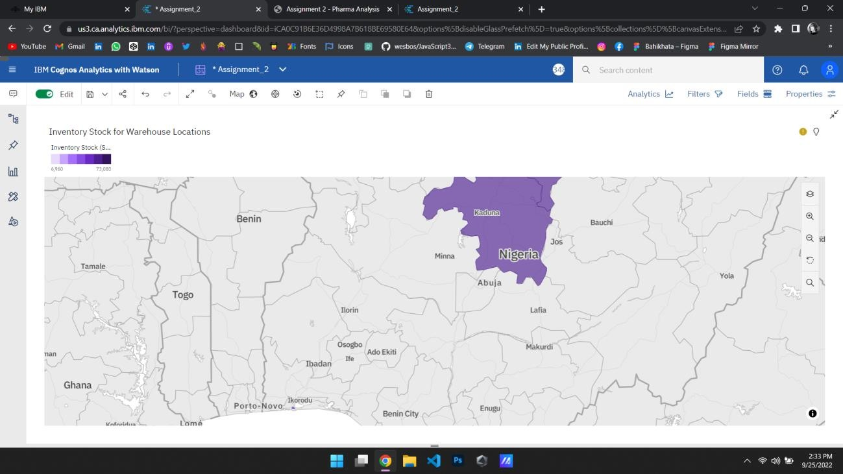



Task 5: Inventory Stock for Warehouse Locations:



Task 6: Sales Trend:

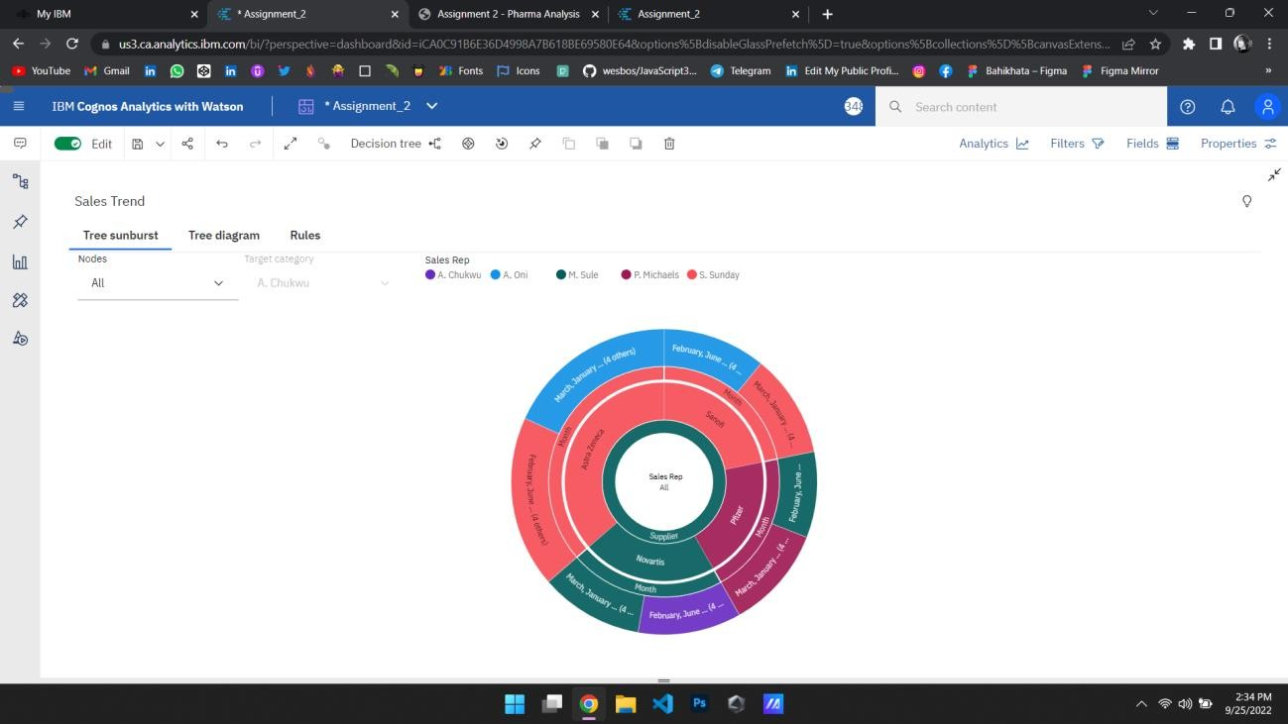

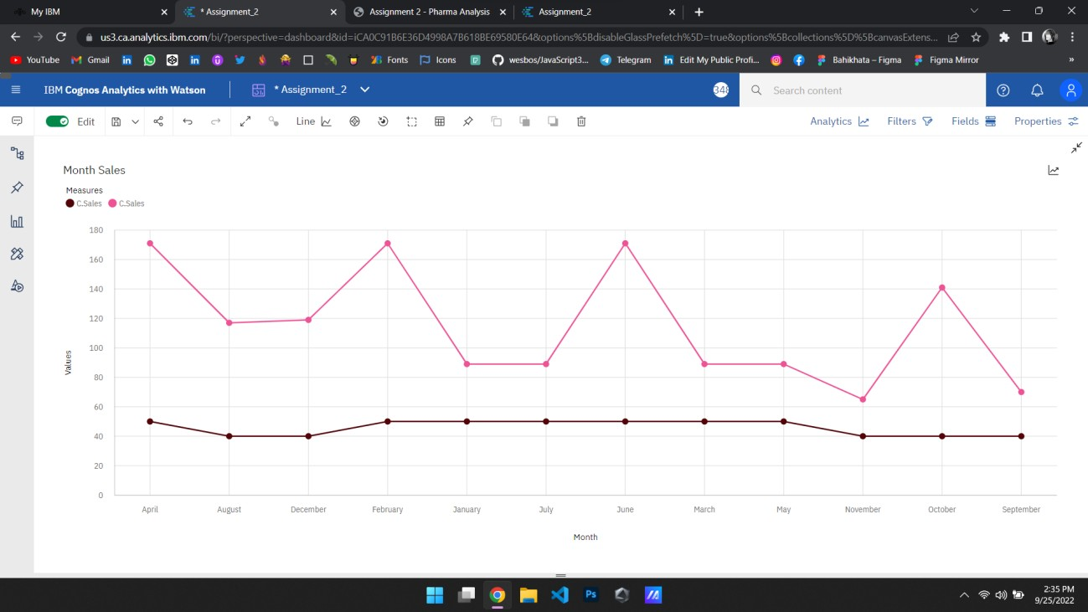



Task 7: Monthly Sales:



Task 8: Actual and Received Inventory by Month:

